**Task 1**

This is the data.



Write a query to list out for each author and doctor the number of episodes made, but restrict your output to show only the author/doctor combinations for which more than 5 episodes have been written.

select a.AuthorName,d.DoctorName,count(e.EpisodeId) from tblAuthor a

inner join tblEpisode e on a.AuthorId= e.AuthorId

inner join tblDoctor d on d.DoctorId= e.DoctorId

group by a.AuthorName,d.DoctorName

having count(e.Episodeid) > 5 order by count(e.Episodeid) desc

Example

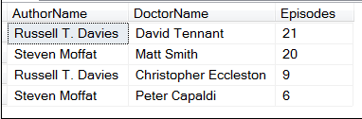

**Task 2**

This is the data.



select 1 + (year(EventDate) - 1) / 100 as century,count(Eventid) NumberofEvent from tblEvent group by (1 + (year(EventDate) - 1) / 100)

Create a query to show the following information:

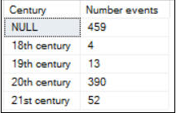

**Task 3**

This is the data.

select EventName,EventDetails from tblEvent where

CountryID not in (select top 30 CountryId from tblCountry order by CountryName desc)

and CategoryID not in (select top 15 CategoryID from tblCategory order by CategoryName desc)



Create a subquery to list out all of those events whose:

* Country id is not in the list of the last 30 country ids in alphabetical order; and
* Category id is not in the list of the last 15 category ids in alphabetical order.

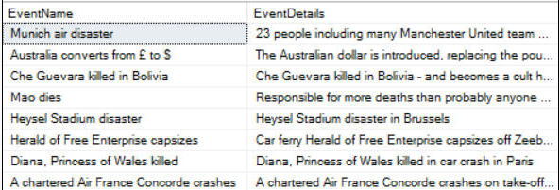

**Task 4**

This is the data.



Use a recursive CTE based on this table to show all of the menus, with breadcrumbs:

Example

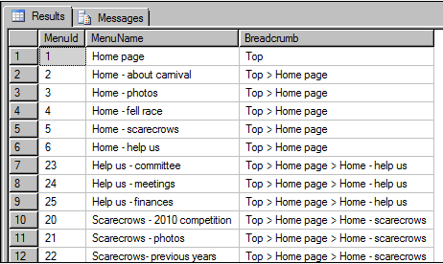

**Task 5**

Write a query to retrieve users from the tables. Input will be given in format 2431,2580' upon receiving the input, you should return user FullNameFL and AdjusterId

Table Name

·         dbo.UserPersonal (Contains User Informations)

·         dbo.Adjuster (Contains User Adjusting Details)

Input

   ‘2431,2580’ (This will be one comma separated string)

Output

   Id               FullNameFL

   -----------------  ----------------------------------------------------------------------------------------------

   4170             Lane Johnson

   1680             Susan Copeland

   4931             Charles Logue

   149              Brent Andrews

   687              Larry Blasingame

   6251             Aaron Paulson

   4                Buddy Ables

   3194             Brian Griffin

   8587             Brian Ward

1972                     Christopher Dean